МИНОБРНАУКИ РОССИИ

МОСКОВСКИЙ ГОСУДАРСТВЕННЫЙ
УНИВЕРСИТЕТ ИНФОРМАЦИОННЫХ ТЕХНОЛОГИЙ, РАДИОТЕХНИКИ И ЭЛЕКТРОНИКИ
МИРЭА

Н.И. ЧЕРНОВА, Н.В. КАТАХОВА, Л.И. ПЕТРОВА,
Н.Б. БОГУШ.

БИЗНЕС-АНГЛИЙСКИЙ ЯЗЫК.
FEEL FREE IN YOUR BUSINESS ENGLISH

УЧЕБНОЕ ПОСОБИЕ
для магистрантов всех направлений

МОСКВА МИРЭА 2015
УДК 811.111: 334:17
ББК 81.432.1+87.751.2
Б59

Утверждено редакционно-издательским советом МИРЭА
в качестве учебного пособия для магистрантов

Подготовлено на кафедре иностранных языков
Рецензенты: к.э.н. Т.Ю. Гавриленко, проф. Ю.И. Михайлов

Н.И. Чернова.
Бизнес-английский язык. Feel free in your business English: учебное пособие / Н.И. Чернова, Н.В.Катахова, Л.И. Петрова, Н.Б. Богуш. — М: МИРЭА, 2015. — с. 67
ISBN
Данное пособие содержит профессиональную бизнес-лексику, необходимую для формирования общекультурных и профессиональных компетенций в процессе межкультурной профессиональной коммуникации, а также построения речевого и неречевого профессионального поведения с учетом социальных норм поведения, обусловленных бизнес-культурой стран изучаемого языка. Учебное пособие предназначено для магистрантов всех направлений и нацелено на обучение логически верной и аргументированной устной и письменной речи в процессе делового общения. Оно также может быть рекомендовано в качестве дидактического средства для организации самостоятельной работы студентов и аспирантов по дисциплине «Деловой иностранный язык».
ISBN
© Чернова Н.И.,
Катахова Н.В.
Петрова Л.И.,
Богуш Н.Б.б 2015
© МИРЭА, 2015

MODULE I. INTRODUCTIONS

When two people first meet they tell each other their names.

Useful language

For introducing people | Greetings
I’m …/ My name’s | How do you do?
I work for… | Pleased to meet you/ Nice to meet you.
He/she is in sales | Good to see you again
 | Hi! You must be Mike
 | Welcome to Russia.

Asking questions | Replying
Where are you from?/ Where do you come from? | I’m from
What’s the reason for your visit? | I’m here to ……

How is your business doing? /
How are things going in your department? | We are doing OK
Where are you staying? | I’m staying at (name of hotel)
What’s your hotel like? | The hotel is / My room is….
Did you have a nice trip? | There was a delay with the flight

Saying goodbye

See you later

Nice talking to you

Have a good day/ enjoy your visit

Conversations as examples

- Mark: Good morning. I’m Mark. I’m a finance director. I work for a big media company.

Lucy: Hello, my name is Lucy, Lucy Dunkin. I’m a research analyst for an investment bank.

Mark: Nice to meet you.

Lucy: Let me introduce you to my colleague, /please meet my colleague, John Ross. He is my assistant.

Mark: Pleased to meet you, John. Where are you from?

John: I’m from London; I’m here to attend the conference.

- Charles: Can you introduce yourself?

Jack: My name is Jack Keeley. I live in a small city in England near London called St. Albans. I have three teenage children and I run my own small business which works for organizations across the UK, where I help leaders to make decisions together.

Charles: Do you always shake hands when you meet someone?

Jack: I like to shake hands as I like people to feel welcome, to feel important, to feel valued, so yes.

- B: Hello, Jim. This is our new intern, Paula Atkins.

J: Nice to meet you, Paula. I am Jim Davis, I work in sales.

P: Pleased to meet you.

J: How long will you be with us?

P: About three month, maybe longer

B: OK, Jim, see you later.

J: Bye, Paula, enjoy your visit.

B: Now, Paula, how about a drink? Tea or coffee?

Greet people in the class. Remember: you may greet a person either formally or informally. If you name a person by his first name, greet him informally. If you name him by his surname, greet him formally.

Talk about yourself.

Hello. My name is/ I am ……. . I’m from……. . I live in …… . I am married with two children, a boy and a girl. I run my own small business in / I work for an international engineering company/ I am in pharmaceutical business / I work in sales/ I am a director of public relations/ I am an IT consultant/ I work in Human Resources ….. .

Remember the profession names

Accountant, journalist, lawyer, manager, office worker, optician, personal assistant, executive, architect, artist, cashier, consultant, director, doctor, engineer, receptionist, research analyst, sales assistant, technician, telephone operator, trainee.

Complete the chart about yourself, and then introduce yourself to your fellow student.

- Name ……. | 5. Job
- City………. | 6. Interests
- Nationality……… | 7. Favourite sports
- Marital status ……

As the first few seconds of a first meeting of new business partners are the most important to create the right impression, you may need some useful tips to follow:
- check your appearance just before you meet (let your dress be conservative)
- be ready to meet your partner at the appointed time
- greet your partner in a warm and friendly manner
- introduce everyone who is present or have them introduce themselves
- Speak clearly, especially when giving important information
- remember that foreign names are often difficult to catch
- Show interest in the other person by making eye contact when he/she is speaking

Read the following functions 1-8 and match them with the expressions a-h.

1. Greet someone you’ve never met before.
2. Greet someone you often meet.
3. Greet someone you haven’t met but you’ve had contact with him/her by phone or e-mail.
4. Greet someone you’ve met before, some time ago
5. Check someone’s name if you didn’t hear it very well.
6. Introduce yourself.
7. Introduce a colleague.
8. Ask someone what their name is.

- Good to see you again.
- I’m Jan Davis, the Human Resources Manager
- I’m sorry I didn’t catch your name. Can you say it again?
- I’m sorry; I don’t know your name.
- Hi! How are you?
- This is Frank Morris. He is in charge of exports.
- Good morning. Pleased to meet you.
- Nice to meet you at last.

Take turns to ask the questions. Answer your partner’s questions as fully as you can.

- Who do you work for?
- What type of company is that?
- What do you do in your job?
- What else does your job involve?
- What are you working on at the moment?

Try to use the following language when answering your partner’s questions

I work for…, I am an engineer, finance director in… I started in and now I work in… I am in charge of / responsible for … the overall performance of the group… I take the final responsibility for profits. I am responsible for the company’s accounting practice/company’s relationships with… It’s my job to answer questions…I report to… I manage a department … of the company… My job involves …I am a sales manager for… I do travel a lot on my business, I run my own small business, I have my own company, I manage a web team at an IT company, I work full time, I am a part-time worker, I work flexible hours, there is a lot of pressure in my job, I really enjoy working with my colleagues, I have/I don’t have enough time for my family.
You may also need: to attend meetings, to make phone calls, to make presentations, to negotiate deals, to show visitors around, to describe technical machinery or processes, to discuss figures, to read. To write, to socialize, to make decisions, to be team captain, to implement ideas or plans, to advise people, to solve complaint problems.

Now your task is: Make up a sample-based and coherent personal profile of yours, consider it well in terms of grammar and vocabulary. You are to incorporate 6 basic elements into it: your general studies, your English classes, your social life, your family issues, your working/studying environment, how to arrange them properly. Mind: it is a speaking point, so you are to recite your profile, but not to read it out!

Job applications
Be familiar with the recommendation offered
- Preparation
It is to prepare carefully for a job application. You need to think about:
- Your own experience, interests, skills and personal qualities;
- The job and organization advertising it.

The key to effective job application is thorough preparation. You need to think and research - yourself and the job.

Start researching yourself thinking about the following areas: experience, interests, skills, personal qualities.

Experience:
Your notes on your experience should certainly include:
- Education
- Any professional training
- Periods of employment (include both part-time job and full-time one)
- Periods in which focused on a particular activity (for example, periods of foreign travels)
- Any voluntary work you have done.
Interests
Things you do in your spare time, when you are not working. They are one of the ways in which your personality can be defined. They also might indicate skills you have which are not currently used at work.
Skills
Make sure to include not only skills related to your trade or profession but also personal ones which may be relevant to a job application, for example:

Organizing events | training staff | interviewing
Chairing meetings | making presentations | supervising
Trouble-shooting | meeting the public

Personal qualities

Here are some qualities.

Accurate | adaptable | careful
Can work under pressure | cooperative | competent
Dedicated | energetic | good communicator
Good sense of humor | lively
Flexible | friendly | extrovert
Independent worker | organized | positive
Loyal | practical | self-motivated
Thoughtful | sensitive | reliable
Self-confident | hard-working | organized
Introvert | committed | logical

The CV

The Oxford English Dictionary defines a curriculum vitae or CV as a brief account of one’s life and career as it required in an application for employment.

Traditionally the CV is a bald recital of basic information.

- Full name
- Address and telephone number
- Age, date and place of birth
- Nationality
- Marital status
- Number of children
- Dates and places of primary, secondary and higher education
- Educational qualifications (public examinations taken and grades /degrees achieved).
- Employment record, including details of each period of employment : company/organization, position held, dates
- More detailed information about current position held (often including salary)
- Interests
- Names of two people who will provide references (often one as character reference and one as a professional/work reference).

Please note: there are many different ways to prepare a CV, depending on the nationality of the company that you are applying to. In some countries or fields the traditional chronological development through education and experience is in favour of setting out personal skills acquired in order to entice prospective employers. There is a current trend in using recruitment consultants, who initiate employees to e-mail CVs direct or advertise themselves on the Internet.

Please study the CV given below and practice to write your own CV as a homework assignment. You can also prepare some CVs in your class group together.

Personal Details
Michael Brown
76, Lower Green Road, Newbery. Berks, RG23 SRT
01892 293479 E-mail: michael. brown @caledonia. net
23d February 1971
British
Divorced
Children (one child, ten years old)
Education
1993-1994 London Chamber of Commerce and Industry
Diploma in Public Relations
1989-1992 University of London
BA (Honours) in Public Relations
1982-1989 Gondersfield High School
German (A), English (B), History (B), Geography(C)
Maths (C)
1976-1982 Primary School, Huyton
Professional Experience
2005 – present Sales Manager: Brown-Petlow, Solihull
Responsible for department of 12 and sales team of
24 representatives
1997-2005 Assistant Sales Manager, Alders & Green, Leicester
1992-1997 Graduate trainee with Myersons-Chemco Ltd.
Skills
IT Office 2000 and Windows NT, Excel, Internet,
Powerpoint
Languages Good standard of German, basic knowledge of
French
Additional Driving license (car), swimming instructor,
Member Solihull Round Table

Interests (Activities) Golf, scuba diving

References Mrs. Mary Hayling Mr. Peter Smithson
23 Orchard Close The Meadows
Graystoke Peterlee
Essex Reading
CM23 8YH RG12 8EV
(phone: 01234 567890) (phone: 04321 098765)

You may prepare your CV in a functional layout. This kind of CV is organized by skills and qualities and the functions you could use as headings might be :
- Presenting the product range;
- Customer care;
- Information technology
- A good sales record in all positions
Under each one you can provide further details of specific experience. You can focus on your strengths to make your CV both a “selling document” and a proof that you can write good English.

One more CV example
Task: Read the CV below and complete it with these headings.
- Education and training.
- Main activities and responsibilities.
- Organizational skills.
- Personal information.
- Personal skills.
- Position held.
- Subject/occupational skills covered.
- Technical skills.
- Title of qualification awarded.
- Work experience.

Curriculum Vitae
(1)____________________
First nave/Surname Sukvinder Dhal
Address 145 New Ferry Road, Queens Bridge, Durham, UK
Telephone + (44) 1982 12459
E-mail skvdhl8618@coolmail.com
(2)_____________________
Dates 2011 - present
(3)_____________________ IT Support Technician
(4)_____________________ Provide support to customers of my company’s
networking products, both wireless and wired
Diagnose problems and suggest solutions.
Name and address of employer Agoda Digital Ltd., Garside Industrial Estate,
Sunderland, UK
(5) _____________________
Dates 2009-2011
(6)____________________ BTEC National Diploma for IT Practitioners
(System Support).
(7)_____________________ IT technical support, customer service,
networking (wireless and wired), hardware
installation.
Name and type of organization Conglefield Colledge, Cheshire, UK
providing education and training
Personal skills and competences
Mother tongue(s) Hindi
(8)______________________ I am a good team player at work. I work well
with people from many different backgrounds
People find me friendly and easy to work with
and I understand other people easily. I enjoy
helping customers.
(9) _____________________ I often prepare my team’s schedules. When
problems happen, I often make useful
suggestions; I have good problem-solving
skills. I am very organized; this helps me to
work efficiently. I enjoy taking
responsibly.
(10) ____________________ Setting up both wired and wireless networks,
including WI-FI. Diagnosing problems in
networks. Server administration of both
Linux and Windows operating systems

- The letter of application

The letter of application can be as important as the CV as it often provides the first direct contact between a candidate and an employer and if this letter is not written well it may make a poor impression. So, the CV accompanying letter is an important selling tool and needs careful thought. It also has a number of purposes:
- It allows you to sell yourself by pointing out key features of your CV:
how your skills and experience fit you for this particular position;
- It gives you the opportunity to include material that is not in CV, especially personal qualities;
- It shows your perspective employer that you know how to write a letter.
The letter of application should follow the general guidelines for all business letters that means it should have an introduction, a body, and a conclusion.
In the introduction part you should detail the job you are applying for and the circumstances that have led to this (for example, an advertisement, or the recommendation of an agency).
The body of the letter provides you with an opportunity to present yourself to the employer:
- Tell the reader about your present job and why you are looking to move on;
- Explain why you are suitable for this job;
- Emphasize the skills you have which make you particularly suitable for the job;
- List briefly the personal qualities you would bring to it;
- Answer any specific questions posed by the advert or job details.

It is important not to write too much, however. Two, or at most three, short punchy paragraphs are much more effective than two sides of rambling prose.

The conclusion should round the letter off, leaving the reader with a positive image/ It should sum up briefly the selling points made in the body of the letter, mention any items (including the CV) you are inclosing, and express willingness to provide any further information that the reader may want.
Here is an example of the accompanying letter.

52 Hanover Street, Edinburgh
EH2 5LM
UK
8th March 2014

Karen Gilbert
Patagonia Gmbh
Reitmorstrasse 50
8000 Munich 22
Germany

Dear Mr. Karen

I am writing to apply for the position which was advertised last week in the Independent.
Although I am presently employed by a none-profit making organization, it has always been my intention to work in a commercial environment. I would particularly welcome the chance to work for your company as I have long admired both the quality of the products that it provides and its position as a defender of environmental causes. As you will notice on my enclosed CV, the job you are offering suits my personal and professional interests as well.
My work experience has familiarized me with many of the challenges involved in public relations today. I am sure that this together with my understanding of the needs and expectations of sport and nature enthusiasts would be extremely relevant to the position. Moreover, as I am fluent in German language, I would definitely enjoy working in a German – speaking environment.
I would be pleased to discuss my curriculum vitae with you in more detail at an interview. In the meantime, please do not hesitate to contact me if you require further information.
I look forward to hearing from you.
Sally Scott
Yours sincerely.

Assignment:
Just imagine you need to write an application letter for the position in a company you have been dreaming to be employed since you were a graduate. Following the tips and the example letter presented make up your own one.

Interview
Like getting married or moving house, a new job can change our lives and this means that a job interview is very important. It is when the interviewer must decide who the best person is for the job. So, if you want the job, it seems like a good idea to help the interviewer to find out you are the best, better than all other applicants. Yet some people do nothing and seem to think that if they want job, that is a good enough reason for it to be theirs.

Here is some advice about job interview.
1. Find out about the company before the interview.
It’s a good idea to apply for company which can give you a range of experience.
2. Make sure you have a clear idea of what type of job you want.
Before the interview decide why you would be good for the company.
- During the interview try to seem relaxed and friendly.
It is a good idea to look at the interviewers. Make sure you tell the interviewer if you are good at organizing your work or working in team.
- Try to make sure you arrive in time for the interview.
- When the interviewer asks a question try to think of some relevant to say.

Careful preparation is again important and has the following main stages:
- Introductions and explanations.
- Questions asked of you.
- Questions you ask
- Conclusion

Warm up
Think and talk about these questions.

- Have you ever had a job interview? If so, did you enjoy the interview? Why? Or why not?
- What do you think interviewers enjoy or don’t enjoy about interviewing people for a job?

Useful language to keep in mind to get ready for an interview.

Skills
What are you good at? | People say that I am good at…  My main skills are…

Experience
What did you learn from your last job?  What didn’t you like about your last job? | I learned how to ….  Well, I had a problem with…

Interests
What did you do in your free time?  What are your main interests? | I really enjoy…  I spend a lot of time…

Future plans
What do you want to do in the future? | My main name is to …
Ex.1 Here are some questions that are often asked in job interviews (1-5). Match each one with the best answer (A-F). There is one answer that you won’t need.
- What are your greatest strengths?
- What are your greatest weaknesses?
- Why do you want to work for this company?
- What can you contribute to this company?
- What are your career goals?

- I sometimes spend too long thinking about alternatives before I make a decision.
- I have plenty of experience of managing projects, and that fits your way of working.
- I know there will be an opportunity to learn more about production.
- I have a degree in business studies and a certificate in management
- I work hard and I manage my time well. For example, every Monday morning I plan what I need to do that week.
- I’d like to get experience and become a manager within the next five years.

Module 2. JOBS AND LEISURE

Warm up
- What do you want from work? Discuss in pairs. While discussing use the following word partnerships:
High salary; long holidays; helpful colleagues; a friendly boss; travel opportunities; fast promotion; flexible hours; sports facilities; company car; parking facilities; mobile phone, I enjoy the most about my work that there is no such thing for me as a typical day because I…
Say now about yourself answering the following questions
When are you busy during the day?
When are the quiet times for you?
Which days are you busy during the week?
When are the busy times during the month/year?
When are the quiet times during the month/year?
Which moments in the year do you particular enjoy? Why?
How many days’ holiday per year do you think people should get?
Tell your partner about your typical working day and your holidays.
I am a product manager/I am engaged in … business. I work for… company.
I get up…
I travel to work by…
I arrive at work… When I get to the office, I have a meeting…
I check my e-mail…
I am busy…
I have lunch at… At lunch time I usually…
At work, I spend a lot of time… I do work very long hours …
What I enjoy the most about the work that I do is that… /I feel about my job ….
I finish my office day ….
I usually do not leave the office before…
I travel on business…
I have /I don’t have enough time for leisure…
I like to spend all my free time with….
At the weekend, I … or ….
What’s important for me is …
Now talk about your leisure activities
At the weekends, I spend a lot of time…
I try to go out ….as it is very relaxing…I think it is very important to get outside into the fresh air and…
On Saturday nights, I meet my friends for a… or we go ….
On Saturday evenings, I sometimes invite my friends round for …
I absolutely like quiet weekends…
I sometimes go for a meal at…
I love sports I really enjoy going to… I also like … I am interested in … but I am not very good at…
I often work on the weekend, so my work-life balance is not good... Too much work, not enough time for leisure activities, not enough time for my family...
To make a conversation you may need the following questions:
What do you like to do in your spare time?
How do you spend your evenings/weekends?
What’ your favourite hobby/pastime?
Where are you going for your holiday this year?
Can you tell me about any interesting places to visit?
What/how about you?
What do you usually do after work?
Work in pairs. Tell your partner how you feel about your work or studies. Use the phrases given below.
Work in pairs. Tell your partner about what you do in your free time. Use the phrases given below.
Change partners. Tell your new partner about your likes and dislikes.

Asking questions

What do you do at work/in your studies?
during the day?
in your free time?
at the week end?
after work?
in the evening?

Expressing feelings

I like/love… | I don’t like…
I am really into… | I am not into….
I am keen on… | he is not really keen on…
I really enjoy… | She does not enjoy…
I am interested in… | We are not interested in …

Now match the questions (1-6) to the answers (a-f).

- What do you do in your job? | A. Usually about six o’clock
- What do you like best about your job? | B. I manage a web team at an IT company.
- How many hours a week do you work/study? | C. From time to time. We sometimes go to a café or restaurant.
- When do you finish work? | D. I play golf
- Do you meet your colleagues after work? | E. I work flexible hours, which is great.
- What do you do in your free time? | F. Between 30 and 35 hours.

Interview a staff member and ask questions using the questions suggested. Think of the additional ones.
Position: (What / job?)
Routine: (What / do/ each day?)
Hours: (What / hours/ work?)
Breaks: (How often / breaks?)
Lunch: (When and where / have lunch?)
Feelings about job: (What / like/ not like about job?)
Travelling: (Have / ever /travelled/ abroad/ business?) (Where/ go?)
Polite expressions

We use a lot of standard polite expressions in social situations. Here are examples of some important ones.

Asking people to do things | Agreeing | Refusing
Can you…? | Yes, certainly | I am sorry, but …
Will you…? | Yes, of course | I am afraid…
Could you…? | No, not at all
Would you…?
Could you possibly…?

Asking for permission | Agreeing | Refusing
Can I…? | Yes, certainly | I am sorry, but…
Could I…? | Yes, of course | I am afraid…
May I …? | Please do
Could I possibly…? | By all means
Would you mind if I used your phone? | No, not at all

Thanking | Replies
Thanks | You are welcome
Thank you very much indeed | Don’t mention it
It’s very good of you | Not at all
 | It’s a pleasure

Apologizing | Replies
Sorry | It’s OK
I am extremely sorry | No problem
 | It doesn’t matter
 | Don’t worry about it

Offering help | Accepting | Refusing
Do you want a hand? | That would be great | No, it’s all right, thanks
Can I…? | Yes please. Thank you very much | That’s kind of you, but I can manage.

Work - life balance.
Read the text and answer the following questions.
- What is a good work-life balance for you?
- Why is work-life balance so important for you?
- Do you like working under pressure? Why? Why not?
- Is it important to have a certain level of stress in the workplace?
- What should companies do to reduce stress at work?
- How important is the working environment in reducing stress?
Work-life balance is the ability to give a good amount of time to your work and to outside interests, e.g. family. It is an interesting question as everybody has a different sense of what works for him/her. People like work that is rewarding and gives them satisfaction. However, the fact is that most jobs nowadays have become demanding with longer hours and greater pressure. That is why more and more people want to get away from what they call the rat race, the feeling that work is too competitive. They are looking for lifestyle that is less stressful or completely unstressful. They are looking for more relaxed ways of living and working. Some of them choose to work from home to be nearer to their families. People are looking for a better quality of life, healthier work-life balance. Choosing to work in less stressful ways is known as rebalancing. Specialists are sure that stress might be part of people’s job satisfaction. There are lots of things that can make people feel under pressure at work –for example, having too much to do, not feeling in control, and also not having good relationships with the people that they work with. All of these things can build up, and when pressure gets too much, it spills over into feelings of stress. Many companies can really help their employees by being flexible in how they expect staff to work. To solve the problem if some employees do not like travelling in rush hour, they could come in a little bit early and leave a little bit early or company ‘management could ban staff from working at weekends or introduce flexitime for parents with young children or perhaps, allow some staff work from home. Not a bad idea to set up a counseling service with a professional counselor. Staff could go there and talk about their problems.
Speak on the following.
What are the most stressful situations for you both in your everyday life and at work?
What do you do to relax? Which of the activities are the most effective for you?
- Many employees feel uncertain about their jobs and careers when working for a company. They worry about the future, they are constantly anxious.
- Some staff are stressed because they feel they have no control over their work and they do not participate in decisions. They feel worthless and are not valued by management.

What about you? Comment on point 1 and 2.
50 ways to cope with stress.

Get up 15 minutes earlier. Prepare for the morning the night before. Don’t rely on your memory…write things down. Repair things that don’t work properly. Make duplicate keys. Say ‘no’ more often. Set priorities in your life. Avoid negative people. Always make copies of important papers. Ask for help with jobs you dislike. Break large tasks into bite sized portions. Look at problems as challenges. Smile more. Be prepared for rain. Schedule a playtime into every day. Avoid tight fitting clothes. Take a bubble bath. Believe in you. Visualize yourself winning. Develop a sense of humour. Stop thinking tomorrow will be a better today. Have goals for yourself. Say hello to a stranger. Look up at the stars. Practice breathing slowly. Do brand new things. Stop a bad habit. Take stock of your achievements. Do it today. Strive for excellence, not perfection. Look at a work of art. Maintain your weight. Plant a tree. Stand up and stretch. Always have a plan B. Learn a new doodle. Learn to meet your own needs. Become a better listener. Know your limitations and let others know them too. Throw a paper airplane. Exercise every day. Get to work early. Clean out one closet. Take a different route to work. Leave work early (with permission). Remember you always have options. Quit trying to ‘fix’ other people. Get enough sleep. Praise other people. Relax, take each day at a time… You have the rest of your life to live.

Arranging a visit

An invitation

…We would be very pleased if you could visit our company …
Other similar phrases: We are holding a conference in London and would be pleased if you could attend. We would like to invite you to an evening reception. (The formal language of invitation).
Please join us for lunch tomorrow. Would you like to visit our new factory? (The informal ways to invite people).
Please let us know your availability. (Formal)
When would be convenient? Are you free on Tuesday? (Informal)

Replying to an invitation
Thank you for the invitation to visit your company.
Other similar phases: I was very pleased to receive your invitation.
Thanks for inviting me. Thanks for the invite (Informal)
I look forward to your confirmation. OR Could you please confirm this? Can you confirm as soon as possible?
I am writing to confirm details of your visit to our company next week.
See you on Friday. (Informal ending to an email confirming a planned meeting /visit). A more formal ending would be: I look forward to meeting you on Friday.

Travel arrangements.
Here are some notes
I’ve put together the following itinerary. The agent has changed the itinerary. I’ve fixed the itinerary for our Japan trip.
Departure from Milan at 11:05 on flight BA68, arriving Manchester at ….
Note the following prepositions of place and time about arrangements.
The plane departs from Paris at 8:00
I am travelling on Flight KLM646 to Osaka.
The Lufthansa flight leaves London at 7:30 on Wednesday morning and there is a return flight on Thursday evening at 17:00.
The train arrives at 18:00.
The conference starts at 9 a.m. tomorrow.
Coaches leave the airport every thirty minutes.
We are leaving at midday.
I arrive at Terminal 3 at 19:00
Pick up by company car at 8:00. Also: An airport pick-up can be arranged. I’ll pick you up at the station.
I’m going to Paris in the morning.
I’m meeting the Finance Director at 2 p.m.
I’m catching the early train.

Making a booking
I’m booking the KLM’s flight today.
Shall I reserve you a seat on the same flights? Let me know if this suits you.

Confirming a reservation
I am writing to confirm the reservation, made by phone this morning, for two single rooms at the Hotel Sorbonne on May 24, for Ms. Scheele and Mr. Moure.
I’m writing to change my reservation.
I am afraid I have to cancel my reservation.
Can I check my reservation?

Warm up
Discuss these questions with a partner.
- How often do you travel by air, rail, road and sea?
- Do you enjoy travelling? What don’t you like about it?
- Put the following in order of importance to you when you travel.
Comfort | safety | price | reliability | speed
You may need the following words and phrases:

What I really like/don’t like is the way airlines/railways… treat people, good/poor quality of food, I prefer…, I like … but I don’t enjoy being in railway stations… There are no enough baggage trolleys, it’s really inconvenient. Departure board is full of flight delays and cancellations. I must be really unlucky because I seem always to be a victim of lost or delayed luggage. What I really hate is jet lag as I often travel a lot on business. My last overseas business trip was a nightmare from start to finish. My choice of air/rail/road/sea is dictated by convenience. Well-trained, energetic staff. I use business/economy class. To get special treatment. The attitude of crew and staff. I usually book myself into a small hotel, called…The hotel is within walking distance of the conference centre/sea/trading centre… The food and service are good, so I can’t complain.

Dealing with problems

Some useful phrases
I am sorry to say that we may not be able to meet the agreed schedule.
I am/I was sorry to hear about it. I am sorry to tell/inform you that…. (here to meet means to keep to).
We will fall behind schedule …
We will miss the deadline
You assured us that this schedule was guaranteed … You promised us that you would keep to the schedule.

Unacceptable services
We are very unhappy with the level of service …
Some strong complaints:
We were very dissatisfied with … Your level of service is unsatisfactory. These delays are totally unacceptable.
The sales department rarely answer the phone.
The goods never arrive on time.
We often need to remind you.
Reply
I was very sorry to hear about the problems you have experienced.
I expect to receive the report by the end of this week.
I’m hoping to receive the order by Wednesday.
I expect to hear from you tomorrow.
We apologize for any misunderstanding caused by the information on our website. We do try to keep our website up-to-date and I have discussed this matter with our website manager.
I sincerely apologize for … My sincere apologies.
I regret that we cannot deliver goods on Sundays.
I am afraid we can’t accept …
Some useful phrases for enquiries
We are looking for a new supplier.
We are very interested in your new range of products/ in ordering from you ...
We are interested in doing business with your company.
Please send us a current price list. Could you (please) send a list of your products …

Thank you for your interest in our products. Thank you for requesting information about…
Thank you for enquiring about…
I have attached a copy of our latest company brochure.
I will send you a copy of our new catalogue.
I would be grateful if you could send me further information… Could you please send me …
You will find further information on our website. More details are available on the website.
Visit our website at…
We are having some problems with the new machine. What would you advise us to do?
Who would you recommend? I can strongly recommend…
With reference to your enquiry/ e-mail…
Thank you for your enquiry. Thank you for contacting us.
I enclose a copy of our latest company brochure. I have enclosed the report. The report is enclosed.

The following phrases are often used to make suggestions
Suggestions | Responses
I think we should… | I don’t think we should…
How about…? | I am not sure about that
We could… | That might be the answer
We’d better… | That’ s a good idea
Why don’t we… | No, that’s simply not feasible

PRACTICE

Complete the sentences with a preposition.
Example: Many thanks for your prompt reply.
- I have put some information_____________ the post.
- We believe _______________ buying from local suppliers.
- We are looking _____________ a new supplier.
- I have forwarded your enquiry _____________BMES.
- Where can I buy spare parts _____________ our machinery?
- I am interested __________ your new range of furniture.
- __________ reference __________ your enquiry, I have attached our latest brochure.

Ex.1. Match the two parts of the sentences used in making enquiries.
- I’d like to know | a. some more information about our products.
- We are having problems | b. to our brochure.
- We can recommend | c. arranging a suitable delivery date.
- We are looking | d. you could send us more information.
- I’ll send you | e. where we can buy spare parts.
- Please refer | f. a supplier in London.
- We would like to arrange | g. on your website.
- We would be grateful if | h. for a new supplier.
- I couldn’t find the information | i. a visit
Module 3
Communications
A communication can be verbal when we use words to communicate with people. When we hear someone talking, we notice whether they are friendly or unfriendly, interested or bored, certain or uncertain, and so on. Therefore, communication includes both what we say and how we say. Body language, also called nonverbal communication is an important part. Different cultures may use different signals, though: shaking head from side to side means “no” in many cultures, but “yes” in some, for example in parts of Bulgaria and Sri Lanka. Feelings can be shown through body language without thinking about it. For example, if a person is bored, he or she may look away from the person speaking to them. Some businesspersons think that the best way for business communication is face-to-face communication for getting information across and things done in business. People also like e-mail and other forms of electronic communication.

Speak on the following ways of communication. Comment on each of the way and say which one is the most suitable for you?
- Letters. | 4. Handwritten notes.
- Face-to-face. | 5. Telephone calls.
- E-mail

Let’s start with such kind of communication as

- Telephoning

Useful language
Making calls | Receiving calls
Can I talk to…?/ Could I speak to…? | Who is calling, please?
This is Maria from the Public Relations Department. | Could you tell me what it’s about?
Is this the sales/finance/marketing department? | I’ll put you through.
I am calling about… | Can you hold?
Could you transfer me to the IT department, please? | He seems to be with someone right
 | now. Can I get him to call you?
Could you tell him/her that I called? | I’m afraid there’s no answer. Can I
 | take a message?
Could you ask him/her to call me back? | I’m sorry, there’s no answer.
Can I leave a message, please? | I can transfer you to his/her voice mail.

Now complete the expressions on the right with the same meaning on the left. Consult the USEFUL LANGUAGE. Two prompts are given.
- Can I talk to …? | I’d like to speak to…
- Just a moment… | Thank you ………………………..
- I’ll connect you. | I’ll ………………..………………
- Am I speaking to Marline Brute? | Hello……………….……… Marline Brute?
- Yes, it’s me. | Speaking
- The reason I am calling is………… | Yes, I’m ……….…………… your advert
- Can I have your name and address? | It’s ………………………………..
Telephone quiz
Think of another way of saying
- I’ll connect you
- Just a minute
- The line is busy

You hear the following expressions on the phone. What do you think the speakers mean?
- You are very faint
- He’s tied up at the moment
- Could you read that back to me?
- Can you bear with me for a second?

Choose the polite reply in each of these conversations.

- Can I speak to Mike? | b. Could I have your name please?
- Who are you please? | 1. Yes, I am Anna Long.
- Who is calling please? | 2. Yes, it’s Anna Long
This is Terry Rance | Is she free on Friday?
- Sorry? | 1. No, she isn’t.
- Repeat, please | 2. I am afraid not

Would morning or afternoon suit you best?

- I don’t mind
- I don’t care

Starting and finishing calls

Task 1. Study the table below, and then add the following phrases:

Anyway … | I’ll look forward to seeing you on Tuesday, then
How are things? | Let me know if there is anything I can do
I’m phoning to ask… | Thank you for calling

Welcoming the call | Nice to hear from you.
Polite enquiries | How are you? __________________
Saying why you are phoning | The reason I am phoning is … _____
Indicating you are ready to finish | Right then… ________________________
Offering help | Give me a ring if you have any problems. ________
Confirming future plans | See you on the 26th, then.
 | Until Friday, then/ ______________
Ending on a friendly note | Thanks for your help. ____________
 | Have a nice day
Task 2. Now complete the beginning and ending of the conversation below. Use words and phrases from the table.

The start
A Sandra Parker.
B Hello Sandra, Hans Grass here
A Hans.______________________. ________________________?
B I am fine, thanks._____________________________ with you?
A Not bad at all, thanks
B Sandra, _____________________if you have the details for the multimedia meeting.

The finish
A ____________________________________________________.
B Yes, I’ll do that. Thanks.
A__________________________________________ Friday, then
B Yes. _______________________________________.
A You are welcome._____________________________

Telephone messages
For a telephone message, write down only the important information. Use note form.
Make sure you write the correct telephone number of the caller. Include your name as well.

TELEPHONE MESSAGE

To: Danny Randall Name of caller: Brett Sinclair
Date: 7th April Time: 10.15 a.m.
Message: Meeting place with Adriana changed from Grapp’s to Café Continental. Be there at 9 p.m.
Action: Call back if problems on 01699 720 7743
Signed: Frank Churchill.

Personal messages.

Some useful phrases
Just a quick note to say many thanks.
We really appreciate everything you have done.
Many congratulations on your promotion.
Stay in touch.
This is to let you know that I will be leaving the company.
I was very sorry to hear that you are leaving the company.
It has been a pleasure working with you.
Thanks for all your help.
It would be great to see you here
Good to hear that the event went well.
I am sorry to tell you that George will be on sick leave for two weeks.
Get well soon.
Thank you for reminding me.
Just to check – Is the party in June?
If so, I’d love to come.
Have you remembered that Mona is retiring in June?
II Writing business letters

Business letter format and conventions.
Notice the following points:
Writer’s address or company letterhead: at the top or in the top right-hand corner. The writer’s name is not at the top of the letter.
Reader’s name, position and address: on the left. If you are writing to another country, write the country in the address.
Date: on the right. Various forms of the date are possible.
Opening salutation: Use the name of the reader if you know it, without the initial. If you do not, write Dear Sirs to a company, Dear Sir to a man, Dear Madam to a woman or Dear Sir or Madam if you don’t know the sex of the reader.
Body of the letter: Start a new paragraph for each new idea or subject. Leave a line space between each paragraph. Do not break words at the end of a line.
Closing salutation: Yours faithfully if you do not know the reader’s name, Yours sincerely if you do. (US Yours truly or Sincerely yours).
Signature:
Writer’s name and title (and position in the company, if appropriate). A man uses the title Mr.
The title Mrs shows that a woman is married; Miss shows that she is unmarried; Ms shows only that she is a woman.
Punctuation: in modern business letters punctuation is not used in the headings and endings of a letter. Normal punctuation is used in the body of the letter.

Here is an example of a standard letter.
Hardy
Heyward
7 Nogin Road
Shipsam
Northshire
KT3 49P
18 April 2011
Dear Mr. Loelgen,
It was good to meet you at the seminar in Paris. I am going to be in Amsterdam in June and
I would like to arrange a meeting with as you suggested.
We have many new products that I am sure will interest you.
Could you let me know if you are available on June 5th or 6th?
I look forward to hearing from you soon.
Yours sincerely,
Isabel Hardy
Partner
Please pay special attention to the business letter terminology in the below letter.
30 Empire Drive
Manchester M6 2PQ
Mr. Graham Davis
Assistant Manager
Transworld Freight plc
74Dockside
Vanchester M15 7BJ
Dear Mr. Davis
I saw your advertisement for an Export Manager in the Daily Herald of 7 March and I would
like to apply for the position.
I would be grateful if you could send me an application form and further information about
the salary and working conditions.
I look forward to hearing from you in the near future.
Yours sincerely
Geoffrey Andrews
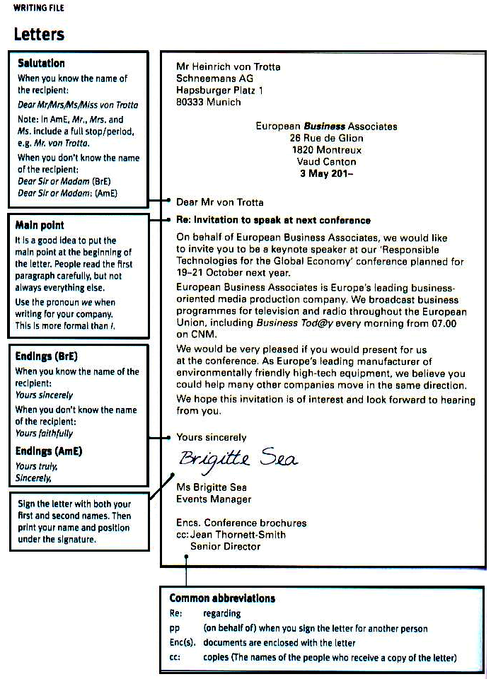
Read the instructions and write a letter (60-90 words). Begin it with a salutation and end politely.
You are a senior manager in the Human Resources Department of a big company. Two days ago, you interviewed candidates applied for the position of a sales manager. Write a letter to the successful candidate. Give the name of the position, the starting day, the salary and number of days of annual leave. Add any other information that will be useful.
You may need the following phrases: We are pleased to inform you; you have been successful in your application for the position…; we would like you to start…; your starting salary will be…; you can take … days’ annual leave; a copy of the contract; confirm the acceptance of the offer.
Now the task for you: read this letter of complaint from a customer and write a reply of 50-60 words to your customer.
Dear Sir or Madam!
This morning we received a consignment of printers from you (Order SN206). On unpacking the boxes, we noticed that all the printers were damaged.
Could you please arrange to send a replacement order as soon as possible and arrange to collect the damaged goods? Hopefully, we will not have to pay for this.
Yours faithfully
Ms. Janine Duval

While replying keep to the layout offered:
- Thanking her for her letter.
- Apologizing for the problem.
- Agreeing to replace the damaged goods today.
- Offering to collect the damaged goods, at no extra cost.

E-mail
Discus or think about these questions
- About how many emails do you send every day?
- Who do you send them to?
- What do you like about emails?
- What don’t you like about them?
E-mails can have a formal business style or a very informal style, similar to spoken English.
Here is an example of an informal letter.
The informal style is most suitable for e-mails within your company and for people whom you know well. The greeting is often Hi, Hello or even How are you? Cheers is a common ending, or sometimes the ending is omitted. Sometimes the writer won’t use capital letters. The style is much closer to spoken than to written English.

To: tony. randall@pricerise.aus
Subject: Goodbye party!
Hi Tony

It’s my last day in the office on Friday, and I’m giving a small goodbye party, 16:30 in room 122. Hope you can come.
CU
Jenny
Sometimes people use abbreviations if they want to save time:
CU – see you
Thx – thanks
RUOK – are you OK?
Approx. – approximately
ASAP – as soon as possible
Attn – for attention
Cc – copy to
ETA – estimated time of arrival
FAO – for the attention
FYI – for your information
N.B. – please note
Pcs – pieces
Pp – on behalf of (per pro)
Re – regarding
Ref. – reference
RSVP – please reply
tba – to be advised/to be agreed
tbc – to be confirmed
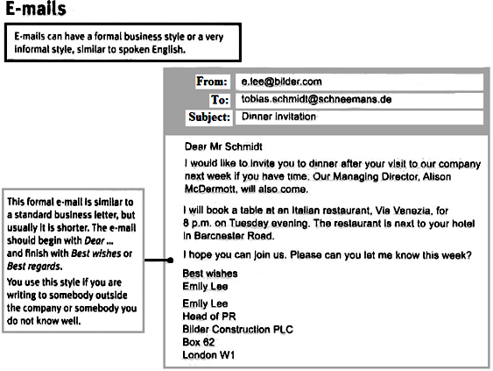

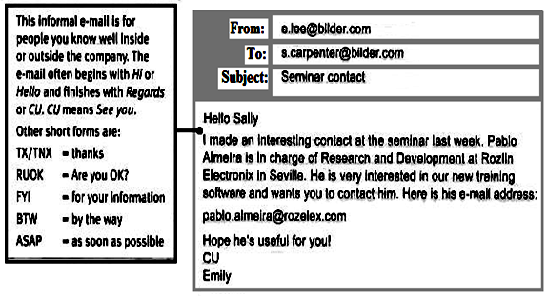

Task: Use the notes and the diary page to write a short e-mail to all staff in the Marketing Department. Write about 30 words, using the useful phrases from the module.
M E S S A G E
For: Pierre From: Hank Date: Friday 10th of May
Pierre,
Can you organize a meeting with all Marketing staff, and email everyone to tell them the details?

- Date – Tuesday 14th May
- Time – look at my diary for the best time – we’ll need 2 hours.
- Subject - to discuss our new brochure
- Venue (the place where the meeting is held) – conference room.
Thanks – see you when I get back from Amsterdam.
Diary Tuesday 14
09:00 Meeting with Jacques until 11:00
10:00 -----------------------------------
11:00 -----------------------------------
12:00 Lunch with Nicole – until 14:00
14:00 -----------------------------------
16:00 Taxi to airport
18:00 Flight KL1058 Amsterdam

Subject:
Attachments: none
To all Marketing staff …………………………………………………….…………………..
…………………………………………………………………………

Short reports
Some useful phrases.
Providing information
Could you send me a short report?
The members of the Board will hold a meeting
There is one thing missing in the report.
The purpose of the visit was to take part in the exhibition.
2000 enquiries were received.
We need to follow up customer enquiries immediately.
We recommend that the new agents should visit the UK.
Just one thing missing - could you please send the cost analysis?
Focus on facts and figures
This report shows sales from 2000-2003
Finance requested a report on expenditure.
We must ensure our prices are competitive.
We suggest looking at a number of alternatives.
Our recommendation is to sign the agreement.
Marketing expenditure rose this year.
Revenue last year exceeded $35K.
66 per cent of our customers are satisfied with our products.
A third of our customers are not satisfied.
Spending rose by 8 per cent last year.
Sales rose substantially.
There was a sharp rise of 40 per cent.
Sales were dropped slightly by 2 per cent.
Compared with last quarter, sales are higher.
The decline in sales is due to increased competition.
Profits rose in the last quarter.
A formal or informal report has a clear title and sub-headings. The format varies depending on the purpose of the report and individual company style, but usually has the following sections:
Title; Background/Introduction; Details/Findings; Actions/Recommendations; Conclusions.
Japan Visit Report
Background
The purpose of the visit was to take part in the Tokyo Technology Exhibition and appoint new agents to help promote our products in the Far East
Details
10 000 visitors attended the Tokyo Exhibition.
2 000enquiries were received and 300 orders were placed.
2 new agents were appointed.
Action/Recommendations.
We need to follow up customer enquiries immediately.
We recommend that the new agents should visit the UK to see our production processes.
Conclusions
The visit was very successful, resulting immediately in new business worth over £300 000.
Japan will be a key market for us for the future.
Report by Janet Robbins 14th October.

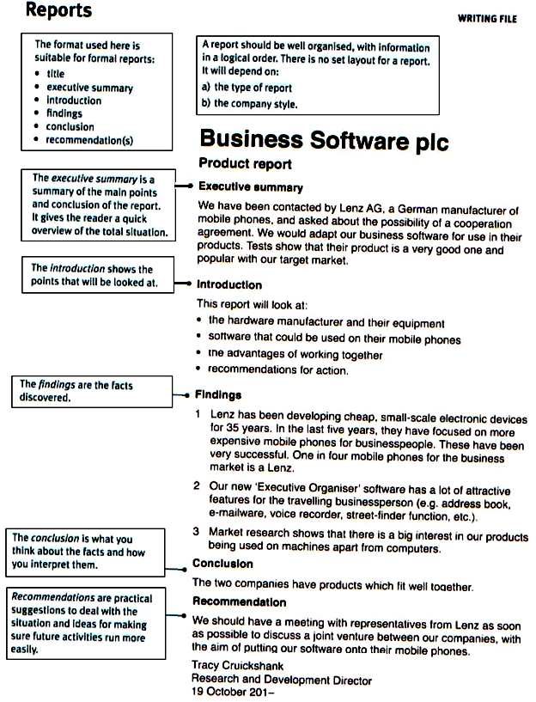
Notices

Notices are used to inform people about changes of plan or to give instructions or warnings.
Notices need a clear heading.
The name and position of the person who wrote the notice and the date must be included.

Staff notice

On Wednesday 29 July, there will be a staff and management meeting to discuss opening a New York branch of the company.
We look forward to hearing your suggestions as to how to ask for volunteers for relocation.
Joanna Grey
Office Manager,
26 July 2013

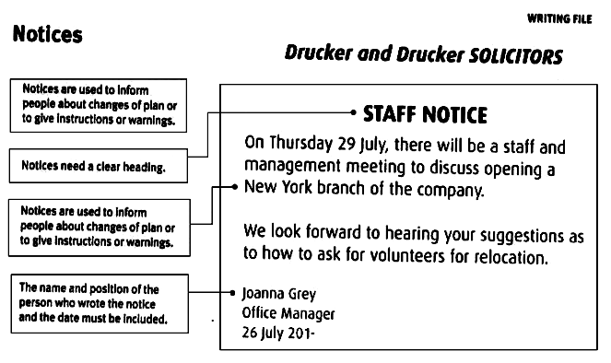
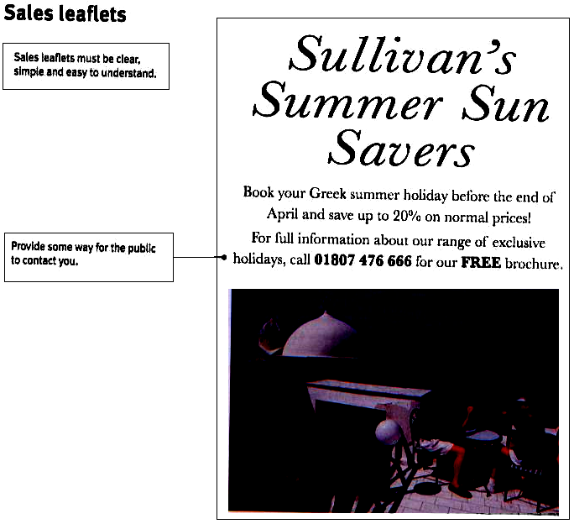

Meetings

Some useful phrases.

We need to set up a meeting. We are holding a meeting at 2 p.m. There will be a staff meeting tomorrow.
Can you let me know your availability next week?
How about next week sometime? What about Tuesday at 10 a.m. in my office?
Can you confirm the meeting on the 17th in Prague? Is 1 p.m. on Wednesday convenient?
I would be very pleased to visit you next Friday.
3 p.m. would be fine with me.
I look forward to seeing you again next week.
The purpose of the meeting is to brief you on the problem.
Please let me know in advance if you are unable to attend
Can you get back to me today?
It’s in my diary.
Can we reschedule for Monday?
Can you let me have all agenda items today please?
We’ll need to circulate the agenda.
Let me know if you want to make any changes.
We’ll need to rearrange the program.
I’ve attached the minutes of the meeting. (minutes of the meeting – are summary of the points discussed and agreed at the meetings).
Is it possible to put this on the agenda for Monday’s meeting?
I’d like to run through the final arrangements.
We need to ensure that everything runs smoothly.
Can you please send out amendment to everyone. (an amendment is a change).
I appreciate your comments on …(to pass something on means to give someone a message or information from someone else).
Your support is greatly appreciated.

An urgent meeting

M E M O R A N D U M (example)

To: all senior manages
From: Rick Lovell, Chief Executive
Date: 20 December
We have a serious problem with the packing of one of our products.
I want to meet urgently with all senior managers at 2 p.m. this afternoon in my office. The purpose of the meeting is to brief you (to give information) on the problem, decide the action we need to take and discuss how to manage the Media.
Please clear your diaries for the whole of the afternoon
RL
Module 4
Companies and products
Warm up
- Name some famous international companies and say what business sectors they are engaged in.
- What famous companies come from your country? What do they d or make? What is special about them?
Use the following useful phrases:
….. is the biggest drinks - manufacturing company, based on (situated in)
….is the biggest automotive producer…/a Japanese car manufacturer
…an information-technology outsourcing company
… the company designs, manufactures and installs wind turbines…
… the company’s strategy is expanding its business in India..
… makes machines and equipment …
The company begins in ….(1995) as a clothing company…
The company makes clothing…
The company employs … people.
The company was started by …
The company produced the world’s best-selling cars
This company is the most admired in the world.
It is a large car-parts company.
It is a small garden- products company
The main company activity is Internet-equipment supplier
Is an international travel services provider
…..is an electronic-goods maker
…..is an IT company
….is one of the largest mobile-phone retailers in Europe.
We have more than 800 stores in 10 countries and the company is growing fast.
Short company profiles
Short company profiles are often found in publicity material. They tell the customer what your company does. They should be short, easy to read and interesting. Make sure the customer can see why your company is the best for him/her. Use bullet points to highlight the main points.

BASLE BANKING SERVICE
Our mission
Basle Banking Service (BBS) is the main provider of solutions in the market for business-to-business financial services. We want to be the number-one partner for your business.

Our services
BBS offers a wide range of services, including sales and investment financing, fund management and insurance.

Benefits for our customers
With our customers, we want to create growth. To do this, we:
- Connect industry and technology know-how with the financial markets;
- Offer new financial products and solutions, which we develop together with our customers;
- Give fast and friendly support.

Here is one more example of the company profile. Read it carefully and write a similar profile for your company or a company you know well.
The GNK Services began in 1989 as a service company in the computer industry. The company produces high-tech security alarms and sells its products all over the world. The company’s head office is in Amsterdam and it has employs a staff of 20. It also has more than 150 people at its factory near Rotterdam. The company launches a number of new products each year. It supplies its products to the security industry and provides domestic alarms for the general public.
The company cares about their customers and wants to meet their needs. The workforce is loyal and dedicated as the employees have always been the most valuable asset.
The company is growing and continuing its excellent performance. Increased production and a strong demand have had a positive effect on the company’s cash flow, so it is able to finance a number of new products. The company’s turnover is $45.2millon, its net profit rose by 5 per cent to $6.9million. The company’s business is highly competitive and it has increased its market share to 20 per cent.

Up-to-date company presentation technique.
In modern English Presentations tend to be much less formal than they were even twenty years ago. Most audience these days prefer a relatively informal approach. However there is a certain structure to the opening of a presentation that you should observe.
- Get people’s attention
- Welcome them
- Introduce yourself
- State the purpose of your presentation
- State how you want to deal with questions

Get people’s attention
If we can start
Perhaps we should begin?
Let’s get started

Welcome them
On behalf of Intel, I’d like to welcome you.
Welcome to Microsoft
Thank you for coming
Good morning, ladies and gentlemen

Introduce yourself
My name is Jane Shaw. I am responsible for travel arrangements
For those of you who don’t know me, my name is Tom Slotter.
I am the new Marketing Manager

State the purpose of your presentation
This morning I’d like to present our new processor
Today I’d like to discuss our failures in the Japanese market and suggest a new approach
What I want to do this morning is to talk to you about our new mobile telephone system

State how you want to deal with questions.
If you have any questions, I’ll be happy to answer them as we go along.
Feel free to ask any questions.
There will be plenty of time for questions at the end.
Perhaps we can leave any questions you have until the end?

Mind the following: People sometimes think of a presentation as a document on a computer: a series of slides that can be shown to any audience. They may talk a little about the slides, but most of the information appears on the screen. This isn’t a good presentation! A presentation like that is likely to be boring, and the audience could read the same information on paper far more quickly that is shown on the screen.
Presentations are effective if the speaker talks to the audience and brings their subject to life. A good presenter can make the audience enjoy themselves and get interested.
So, how to make your presentation interesting?
Make sure you start the presentation by making it clear what you are going to talk about and end it with a summary of what you have said: the presentation should have a beginning, a middle and an end.
One important way is to plan your presentation well. Write some bullet points, listing the points you want to make, and the topics you want to talk about. Just use key words and phrases – nothing more. Then organize them in a logical order. Having this list means that in the middle of the presentation you won’t forget what to talk about next.
Decide where a slide would be useful – maybe a photograph, or a few key words. If you include a slide with a lot of text on it, nobody will be able to read it.
If you do all this, you should be confident about giving the presentation, and will be to seem relaxed – even if you are shaking!

Now some tips on your behavior during the presentation
- Remember to talk to everyone in the room.
- Look at people, and smile from time to time.
- Talk to the audience – don’t write out everything you are going to say and read it aloud. If you do, it will probably sound boring, and you’ll be looking down at your papers instead of looking at the listeners.
- If you have visual aids, don’t turn round to look at them: look at the audience and at your computer screen.
- If you seem confident, your audience will relax – and you’ll feel more confident yourself.
When we are giving a presentation, there are certain key words we use to signpost different stages in our presentation. These words are not difficult to learn but it is absolutely essential that you memorize them and can use them when you are under pressure giving a presentation.

Useful language
Introducing yourself
Hello everyone, I am Ivan Petrov. I am Director of Human Resources at …
Good afternoon, I am Ivan Petrov, Director of Human Resources, …
Good afternoon. It’s great to be here today. As you all know, I am the Head of the Design Department. I’ve been in this job for four years. I’m talking to you today as the manager of the team which developed this new project.
Hello, Thank you all for coming. If everyone is ready, let’s start.

Starting your aim
My purpose today is to talk to you about our company.
Today, I’d like to talk about our new project.
Today I’ll be reporting on the progress we have made since our last meeting.
The object of this morning’s talk is to show you how to put the theory into practice. I’d like to outline the new policy and give you some practical examples.
The results highlight our strengths and weaknesses.

Outlining the presentation
First, I’ll give you some basic information/ There are some important issues I want to go through this morning. Firs, I’d like to outline the main areas of growth.
Next, I’ll talk about our products./After that I’d like to explain how this growth will effect the company’s five-year plan.
Then, I’ll discuss the reasons for our success.
Finally, I’ll tell you about our advertising and marketing./ Finally, I want to focus on the next financial year.

Questions at the end
After you have heard my presentation, I am sure you‘ll have questions. I’ll leave fifteen or twenty minutes at the end for questions, so if anything is unclear please ask me then.
I am very happy to take any questions.
There will be time for questions at the end.
Please save any questions for the end of the talk.
There will be time for questions and comments

Introducing new information
Here are some basic facts
Here are some key facts about our company.

Changing to a new section of the talk
Moving on now to our mission
OK/Right. What about our distribution system?

Ending the presentation
Thanks very much for listening to my presentation
Thanks for coming to my talk.
Are there any questions?

Concluding a section and moving on
To sum up, last month’s sales doubled and this is excellent for this time of the year. Next I’ d like to move on and look at the sales for the following six months.

Ways of telling people that you have information to give them
I have copies of the statistics and tables. I’ll give these to you later./The figures are on the sheet which you can have later.
The handout also contains all the statistics. Please take one each and pass them round. Did everyone get a copy?
Explaining the meaning of abbreviations
IMF – stands for International Monetary Fund.
WTO – stands for World Trade Organization.

Dealing with numbers
From this table you can see that 69 per cent of male shoppers only buy …
Two thirds of those questioned said …
Next year we hope to have 1530 students in nine schools.
For this model of the fridge the temperature must be between 4.3 and 5.6 degrees centigrade.
We expect to make a profit of…
We’ll make a loss of …
You can see the number 50 000 in the third column.
Around 300 people responded to our question.
About 30 per cent were between 18 and 40 and less than 20 per cent were over 40.
The chart shows a significant rise in the number of companies selling cheap modern furniture.
This year the number has gone up to seventy
There has been a significant decrease in the number of people…
The number of staff has stayed the same
Sales of our toothpaste peaked in May.
I believe there’ll be a dramatic rise in private car owners over the next two years
Sales fell dramatically.
Sale began to increase gradually. After April sale fell again and then stayed more or less the same for the rest of the year.

When using visual aids
From this slide you can see… On the next slide you can see …
Let’s look at these figures more closely
Looking at the graph it is interesting to note that the increase in sales happened …
This graph shows the cash flow for the last quarter.
The graph shows our sales figures. The vertical axis represents sales in Australian dollars. Each line on this graph shows one of our top brands.
Let me show you that clip again
This table shows the extra features that come with the new sport car. The features of each model are clearly shown in the table.
The extra features appear in this table.
The models are listed across the top of the table
….on the left in the first column…
The first and second cells …
Survival language
If you get your facts wrong: I am terribly sorry. What I meant to say was this
If you have been going too fast and your audience is having trouble keeping up with you: Let me just recap on that/I want to recap briefly on what I have been saying.
If you have forgotten to make a point: Sorry, I should just mention one other thing.
If you have been too complicated and want to simplify what you said: So, basically, what I am saying is this.
If you are short of time: As we are short of time, this is just a quick summary of the main points.

Thanking people for listening
I’d like to thank you all for taking time out of your busy day to listen to my presentation this afternoon. I hope you will have found it useful.
Well, I have covered the points I needed to present today and the time is now up. Thank you for listening. We just have time for a few questions. Would anyone like to raise any points?

Dealing with questions
When you get a question, comment on this first. This will give you time to think.
- that’s a good question
- I’m glad you’ve asked that question
- A good question
- I’m sorry, but I don’t have that information to hand
- I’m afraid I can’t answer that
- As I said earlier,…
- I did mention that
- I don’t see the connection
- I think that is a very different issue.

Here are some ways of dealing with questions when you are the SPEAKER:
When you do not want to answer:
To be honest, I am not really the person to ask about that
When someone interrupts you:
Sorry, could I just finish?
When you realize they don’t understand what you said:
Perhaps I didn’t make myself clear. What I was trying to say was…
To close off the presentation:
If there are no questions, we should stop there.

Here are some ways of getting an answer when you are the QUESTIONER:
When the answer doesn’t give you the information you want:
Yes, that may be so, but what I want to know is…
When the answer is evasive:
Yes, but you still haven’t answer my question.
If you don’t agree:
That may be so, but I still think…
If you are skeptical and want more detail:
Well, I am not so sure. Can you give us an example to illustrate that?

Here is an example of a presentation for you.
Hello. I am Helen Perttonen. I am the marketing manager at AYT, and I am going to you a brief overview of our company. My aim is to outline the main reasons why you should consider AYT for your construction project.
First, I’ll give you some general information about the company. Then I’ll talk about our international operations. And finally, I’ll point out the main reasons for our success.
So, let me start with the company.
AYT was founded in 1912, and it’s one of the oldest building companies in Finland. At first it was purely a construction company, building houses and apartment blocks in the residential construction sector. Now we are also a service company. We don’t just build houses, we offer finance and maintenance services as well.
We are quite a big company with 22,000 employees. Last year we had a turnover of three billion euros, and made a net profit of more than 90 million euros. We are market leaders in Finland, with 32 per cent share of the market. So you can see that we are a strong and successful company.
Well, that was some general information about the company. Now, I’ll move on to our international operations.
We have more than 40 years’ experience of residential construction outside Finland. We have operations in Sweden, the Baltic States and Russia. In fact, more than a quarter of AYT employees work outside Finland. So we have a lot of experience in managing international construction projects.
And so to my final point: the reasons for our success.
Well, firstly, there is our expertise. We have chosen to specialize in building residential houses and apartments so we have excellent knowledge of this area.
Secondly, our quality standards are extremely high – as high as anywhere in the world. So we feel confident in offering long-term guarantees for all our work.
Thirdly, we have excellent project management and cost control. This is important so we can finish each project on time and in budget. It means that our clients don’t have to worry about extra costs mounting up as a result of delays and poor planning.
So - to sum up. I hope to have shown you that we are a well-established company, financially sound and a market leader in the home market. We also have strong international experience in several countries outside Finland. We offer the highest possible standard of construction together with excellent project management. These are the reasons why you should consider AYT for your construction project.
Thank you very much for listening and if you’ve got any questions, please feel free to ask.
Now the task for you: Think about your company or a company you know. Study the language, delivery tips and up-to-date presentation techniques to make up a presentation about the company you will have chosen.
Now let’s move on to product description.
Short product descriptions are often found in catalogues.
Technical product descriptions are normally written in bullet points.
The text focuses on technical details that are important for the reader.

GVC home movie system.
- Digital miniDV camcorder with nylon carrier and 60-minute cassette
- 6.4 cm LCD colour monitor
- 700x digital zoom and digital colour night scope for colour pictures in the dark
- Long- play function and digital picture stabilizer.
Product descriptions for cosmetic products focus more on colour, smell or taste, and how you will feel when you use the product.

Bianca toothpaste
Wake up with Bianca! Bianca toothpaste is made of a refreshing mixture of peppermint and eucalyptus, leaving your mouth clean, fresh and ready to start the day

Presentation of a product
Some tips for you
Any product has its unique selling point or points which bring the product to the public’s attention. When you present a product give information about its features or characteristics, emphasize the benefits or advantages of the product. While presenting a product specify:
- Appearance
- Benefits
- Price
- Special features:

New Desktop Videophone
It’s small and elegant and ideal for the office or for the home or for business trips.
It is easy to set up. All you need is a touch-tone phone. You don’t need a computer or any special software. It’s also very easy to use.
The Desktop Videophone has many features. Firstly, it has full-colour motion video which means you can see the other person’s gestures and changes of expression.
The picture quality is excellent and the adjustable picture setting means you can change to sharp mode to get a fantastically clear image. This, of course, is just ideal for viewing designs or documents. The audio quality is exactly the same as a normal telephone call.
In addition, the Desktop Videophone also has a preview mode so that you can check what you look like before the other person sees you! And finally, the privacy mode is an important feature. You can use it to block the image but keep voice connection.

Multi-lingual Interpreter
It is an electronic interpreter is fluent in 7 languages (English, German, Spanish, French, Italian, Dutch and Swedish) with a working knowledge of over 30,000 words in each language. It includes an automatic spelling correction so you can input foreign words phonetically, a 30-entry name/address databank, full function calculator, metric and currency converters and word games.
Batteries supplied.
7-language translator costs $49.95.

To describe products you may need the following words:
Innovative | dull | eye-catching | fun
High quality | stylish | old-fashioned | traditional
Reliable | high performance | crazy | expensive
Useful | smart | practical | top – of – the – range
Colourful | beautiful | elegant | sporty
Durable | spacious | extra-wide | hand-crafted
Small and slim | attractive

Remember the order of adjectives when describing things
Opinion | Fact
 | size/  length | shape/  width | colour | where it’s from | what it’s made of
Stylish | spacious | oval | black | Turkish | leather | handbag
beautiful | big | square | brown | Italian | leather | folder

Task: Prepare a presentation of your product.
Summaries
When you summaries something, you express the most important facts or points about something in a short and clear form.
Writing a summary involves:
- Selecting the most important ideas or facts from a text.
- Rewriting those ideas/facts in a short, concise form, using your own language.
- Producing a text which is shorter than the original – usually at least half the number of words.

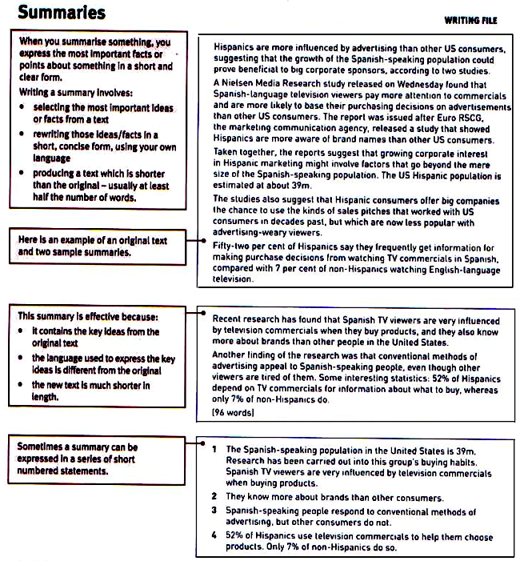
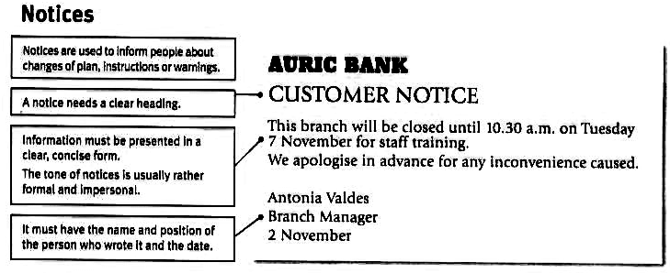
Abstract is a summary of the contents of a book, article, or formal speech, indicating the value of the material presented

Module 5. CULTURES

Culture is the beliefs, way of life, art, and customs that are shared and accepted by people in a particular society. Cultural awareness is much more than simply knowing about a country’s history and geography. It is about understanding how and why cultures work differently. It is also important to understand your own cultural make-up in order to work more effectively, maximize teamwork and strengthen global competence.

World languages
From 14,000 languages in the world 500 years ago, there are now under 7,000. Most are spoken by small numbers of people, while half the world’s population speak one of the top as their first language.

The world’s top five languages, by estimated number of speakers
As a first language As a first or second language
- Chinese (Mandarin) 873m | 1. Chinese (Mandarin) 1052m
- Hindi 366m | 2. English 508m
- Spanish 322m | 3. Hindi 487m
- English 309m | 4. Spanish 417m
- Arabic 206m | 5. Russian 277m
Unlike English, Chinese is mostly spoken as a first language, but around 30m people around the world are learning it, and that number is increasing fast. One major reason is the growing economic importance of China.

For higher education
Two to three million people a year study in another country. 53% of them are taught in English, followed by 11% in French and 9% in German. The number of international students going to English-speaking countries is falling, and more people are studying in English in other countries. Chinese is likely to grow as a language of higher education.

For business
The world’s largest economies
2007 2050(estimated)
- USA | 1. China
- Japan | 2. USA
- Germany | 3. India
What language or languages do you think will be most useful in2050?
- For travel or tourism? - For higher education? - For business?
How important are the following things when doing business in your country?
Are they a) important, b) not important or c) best avoided?
- Exchanging business cards | - being formal or informal
- Shaking hands | - being punctual
- Bowing | - humor
- Kissing | - eye contact
- Small talk before meetings | - giving presents
- Accepting interruption | - being direct (saying exactly what  you think)
- Using first names
- Here is for you the short texts about making appointments, negotiating and business dressing in Japan, Italy, and Brazil. Compare the information of the texts and make up a short summary.
Japanese business style
Making appointments. If you want to make an appointment, but don’t have a connection, a personal call will be more effective than sending a letter. Moreover, a letter requesting an appointment might go unanswered. Punctuality is necessary when doing business here; the Japanese believe it is rude to be late. In Japanese business culture, the working week consists of 48 hours without overtime pay, completed in five and a half days. Larger firms have initiated a five-day week.
Negotiating. What you should know before negotiating. Connections are very helpful in this country, but choose your intermediaries carefully: the Japanese will feel obliged to be loyal to them. Select someone of the same rank as the person with whom he or she will have dealings. Moreover, an intermediary should not be part of either company involved with the deal.
If you know a highly respected, important person in Japan, use his or her endorsement and connection. Before you enter into negotiations, request a consultation, and then ask if you can use the endorsement and connection to further your business efforts. This method of using connections is standard practice among Japanese business people.
Business cards (“meishi”) are an important part of doing business in Japan and key for establishing credentials. Bring a plenty supply, since your Japanese counterparts will be keen to exchange them.
One side of your card should be in English, and the reverse in Japanese. It is an asset to include information such as membership in professional associations.
Cards are presented after a bow or handshake. Present your card with the Japanese side facing up.
People of high rank often have their business cards presented by subordinates.
When you receive another person’s card, make a show of carefully examining it for a few moments and then remarking upon it. Accepting a business cad and then stuffing it into your pocket is considered disrespectful. Writing on a business card is also perceived negatively.
Be especially respectful to your older Japanese counterparts - age equals rank in Japanese business culture.
Negotiations generally have an atmosphere of grave seriousness. However, light conversations as well as light humour are common before meetings or during breaks. Western style jokes should be avoided.
Guidelines for business dress. In Japanese business culture, men traditionally wore conservative suits, typically in blue or grey, with a white shirt and dark tie. Suits are still conservative in medium-sized and larger Japanese companies and government offices, but pastel shirts are now common.
The foreign business in Japan can wear whatever shirt he usually wears… without any negative impact.
Business women should dress conservatively and use jewelry, perfume and makeup only sparing. It is now common for many Japanese women to wear slacks, pant suits and high heels at work, depending on the kind of work they do. Some old-line companies continue to dictate a conservative style.
Summers in low lying areas of Japan are hot and humid. It’s a good idea to pack several changes of clothes, as this culture places an emphasis on maintaining a clean, neat appearance.

Italian business style.
Making appointments. Given the choice, Italians would prefer to do business with even a superficial acquaintance rather than a complete stranger. Since familiarity is so important in Italian business culture, ensure that you find a well-connected contact who can establish the right introductions on your behalf.
In Italian business culture, punctuality is not as much of priority. As a visitor, however, it is usually a good policy to arrive on time. Be prepared to wait 15-45 minutes before your Italian counterpart appears or lets you into his office. Consequently, you may want to bring work, a book or another diversion to fill the time while you wait.
In many cities, such as Rome, there is a long break lasting as long as two hours, from 1:30h.m. to 3:30 p.m. Business is often discussed during this break, over lunch.
Generally, the best time to plan appointments are between 10:00a.m. and 11:00 a.m., and after 3:00 p.m.
Be aware of summer vocation periods. Most firms are closed in August. If you write for an appointment in mid-July, you may not receive a satisfactory reply until September.
Many Italian public holidays follow those of continental Europe butt are usually different from the US, UK and Canada. It is worth checking while planning a trip that a public holiday does no fall in the middle of it as the company and the whole region may close down that day.
Negotiating. Most Italians in Italy do not spear English well, so you will probably need a translator in business situations.
If your Italian counterpart does speak reasonable English it is worth ensuaring that your presentation materials and discussions are kept clear and simple. It is high unlikely that he or she would admit to not understanding parts of the conversation.
When selecting your negotiating team, be aware that Italians generally prefer to do business with only the most important people in any organization. The use of business cards is common and you should have your card translated into Italian on the reserve side.
Moreover, ensure that any advanced educational degrees and your full title or position are featured on both sides of your business card. Italian businesspeople will want to know that they are dealing with an important person.
Guidelines for business dress. Dressing well is a priority here. Your clothing will be perceived as a reflection of your social standing and relative success, as well as your competence as a businessperson.
Generally, dress tends to be on the formal side for both men and women, whether in business or social situations. Do your best to make your clothing choices that are both tasteful and stylish.
Men should wear expensive, sophisticated ties and well-cut dark suits.
Men often wear accessories such as cuff links, tie clips, and stylish watches.
Women are advised to dress simply and wit elegance. Accessorizing is also widely practiced here.
The most commonly worn colours are darker, subdued shades. Brighter colours should be reserved for accessories.
Perfumes and colognes are frequently used by both men and women.
The initial meeting is usually conducted in the office, where your Italian counterparts will make an assessment of you, your proposal and company. The goal, at least for the initial meeting, should be to cultivate feelings of respect and trust between yourself and you Italian colleagues.

Brazilian business style.
Making appointments. Brazilians conduct business only through personal connections. There must also be an implicit understanding that the business relationship will be long-term.
Before putting the resources into a trip, hire a Brazilian contact in your industry that can help you make the right connections. You can find such a person through the Department of Commerce, the American Chamber of Commerce in Brazil, or international organization to which you may already belong. This person will unravel the paperwork gridlock, not help you with setting up meetings. For that you should look for the chamber of commerce or consultants that specialize in this type of business. Trade shows are very good “feel” for the country’s business environment.
Make appointments of any kind at least two weeks in advance. Showing up in an office without an appointment is unacceptable in Brazilian business culture. This is especially true if the person you are there to see is a director of higher position.
Generally, the best times to schedule appointments are between 10:00 a.m. and noon, and 3:00p.m. and 5:00 p.m.
- Avoid scheduling any appointments around “Carnival”.
Poor punctuality is characteristic of Brazilian business culture. Also, traffic in the main cities is chaotic and most of the time is responsible for the delays. But business travelers should still make the effort to be punctual. Always arrive on time for a business meal or meeting at a restaurant. Usually, Brazilian business protocol demands punctuality on these occasions.
Negotiating. Portuguese is the dominant language in Brazil. Be aware that Brazilians do not perceive themselves as Hispanics, and will only take offence if addressed in Spanish. But if you do speak Spanish you may ask to speak it, and they will accept it better. In Brazilian business culture, English is widely spoken.
Be aware that it will probably take several trips to bring the negotiations to a satisfactory conclusion.
Bring a plentiful supply of business cards, since Brazilians tend to be very keen about exchanging them. Ensure that your business cards, promotional and presentation materials, or any other documents required in your dealings are printed in both Portuguese and English.
An important part of Brazilian business protocol is to begin a meeting with good-natured “small talk”. Delving immediately into business will only cause annoyance.
Generally, Brazilians are open to discussing a wide range of subjects, particularly in a business context. They tend to be reticent, however, about discussing their private lives.
Guidelines for business dress. To feel comfortable in Brazil’s sweltering, tropical climate, wear clothing made of light materials and colours that will help keep you cool. Light cottons and similar natural fibers are usually reliable choices.
Keep in mind that the seasons in Brazil are opposite to those in North America; June/July and August is winter and December/January/February is summer.
Appearance is vital in any business culture, however in Brazil the subtle differences are more acceptable; for instance you may wear jeans and a nice shirt and blazer to a meeting and be totally accepted.
If you are wearing a three-piece suit in winter it is fashionable, but not in summer. Most Brazilian suits are tailor made and that is what distinguishes your position. One distinguishing factor is if the materials in your suit are local or imported.
Men should wear dark suits in black, charcoal grey or navy blue, light colours in the summer are acceptable. Select ties that are well-made and conservative,
Ensure that your shoes are polished and kept in excellent condition.
Wardrobe for women includes conservative dresses, suits, pantsuits, skirts and blouses.
Women’s nails should be well cared. Makeup is not a strong feature among Brazilian women, who lean towards the natural look. That famous little black dress‘’ is perfect on all occasions.
The colours of the Brazilian flag are green and yellow. Wearing this colour combination will only make you an object of ridicule. Or, on the other hand, you can say it is an homage, which will be very well accepted.
Now read the notes on Chinese business protocol. How does each piece of advice compare with the situation in your country?

Chinese business protocol and etiquette
Greetings
- You must greet the oldest person first.
- You don’t have to be serious all the time. The Chinese have a great sense of humour. You should be ready to laugh at yourself sometimes.
- You mustn’t move to a first – name basis until advised to. You should address the person by an honorific title and their surname.
Business cards
- You should exchange cards after the initial introduction.
- You should hold the card in both hands when offering it.
- You mustn’t write on someone’s card unless asked you.
Giving gifts
You shouldn’t give flowers, as many Chinese associate these with funerals.
- You mustn’t give four of anything, as four is an unlucky number.
Entertaining at home
- It is a great honour to be invited to someone’s home. If you cannot accept the invitation, you must offer a very good excuse.
- You should arrive on time, remove your shoes, bring a small gift and eat well to show you are enjoying the food.
- You don’t have to eat loudly, but if you slurp or belch, it shows that you are enjoying your food.
For your notes also
- German business people are pretty formal in business, so don’t be surprised at how they address each other. They tend to use family names, not first names, when they talk to each other.
- When meeting you first German people usually shake hands.
- German likes talking about football. They are keen on football. Germans expect to win any match they play and they often do. Football is a great topic of conversation with men.
- When you are invited out to dinner, flowers are very acceptable. They would be a great gift in Germany.
- French people love talking about food. They are very proud of their cuisine, so you can’t go wrong if you introduce that topic into conversation. The French are like the Spanish and Portuguese, they’ll go on for hours talking about local dishes.
- When you are invited out to dinner, flowers are very acceptable. In France most visitors bring flowers for their hostess. Everyone loves to receive them.
Do you know about business culture in Russia? Speak on the topics.
Appearance
- How do men and women dress in business?
- Is casual dress permitted?
Behaviour
- Do people like a lot of personal space? Do they stand close or far away from another person?
- Do staff use first or family names when addressing each other?
Entertainment
- Do businesspeople prefer to entertain guests at home or in a restaurant?
- What advice can you give about gifts?
- What are good/bad topics of conversation?
Meetings
- How important is punctuality in your culture?
- Is the person status important in meetings?

References

  - Business world. English for key business practice (Part I). - М.: МИРЭА, 2007. 48 с. [Методические указания для студентов дневного и вечернего отделений ф-та ЭиУ]
  - Business world. English for key business practice (Part II). - М.: МИРЭА, 2008. 56 с. [Методические указания для студентов дневного и вечернего отделений ф-та ЭиУ]

Keys

Module 2.
Practice (prepositions). 1 -in; 2-in; 3-for; 4-to; 5- for; 6-in; 7-with, to.
Exer.1. 1-e; 2-c; 3-f; 4-h; 5-a; 6-b; 7-I; 8-d; 9-g.
Module 3.
Task1. - Starting and finishing calls.
Polite enquiries: How are things?
Saying why: I am phoning to ask
Ready to finish: Anyway
Offering help: Let me know if there is anything I can do for you.
Future plans: m I’ll look forward to seeing you on Tuesday, then.
Ending: Thank you for calling.
Task 2.
The start
A - Nice to hear from you
B - How are things?
B - I am phoning to ask
The finish
A - Give me a ring if you have any problems.
B - Right. See you.
B - Thanks for your help.
A - Have a nice day.

Учебное издание
Чернова Надежда Ивановна
Катахова Наталия Владимировна
Петрова Людмила Ивановна
Богуш Надежда Борисовна

БИЗНЕС-АНГЛИЙСКИЙ ЯЗЫК.
FEEL FREE IN YOUR BUSINESS ENGLISH

Учебное пособие

Подписано в печать 00.00.2014. Формат 60×84 1/16.
Печ. л. 3,95. Усл. кр.-отт. 15,8.
Тираж 150 экз. Изд. № Заказ №
МИРЭА
119454, Москва, пр. Вернадского, д. 78

